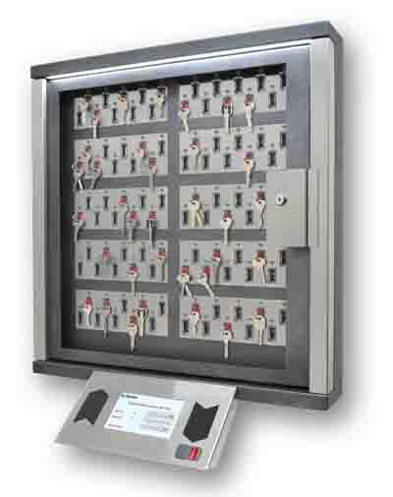
KeyGuard
The Key Management system.

Installation and operation manual

Table of contents
1. Installation of the Key management system 2
1.1. Cabinet installation 2
1.2. Control panel installation 2
1.3. Ethernet connection 3
1.4. Add On cabinet connection 4
1.5. Connection of control signals 6
1.6. Card Reader replacement 7
1.7. Mains and Ground connection 7
1.8. Battery connection 8
1.9. Adding keys 8
1.10. Use of sealed key boxes 8
1.11. Maintenance 8
2. Initial system startup 9
3. Operator Manual 11
3.1. Configuring access modes for keys 11
3.1.1. Issuing a key 11
3.1.2. Return keys 14
3.1.3. Emergency release of the keys 14
4. Technical data 15

Installation of the Key management system

Cabinet installation
Installation of the system unit is carried out by 4 screws (included) to the wall. The wall should be strong enough to carry out 50 kg of the cabinet.

Control panel installation
The control panel is mounted by means of one of the two brackets supplied with the device. One bracket is designed to secure the control panel from the bottom of the unit at an angle of 45%. Another bracket can be used to install the control panel from the right side of the unit.
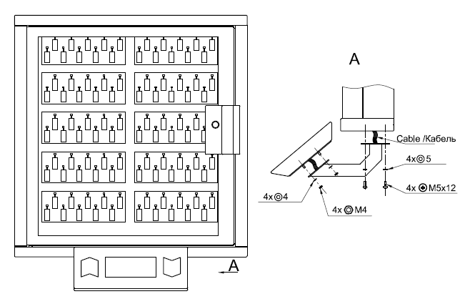

Bottom installation

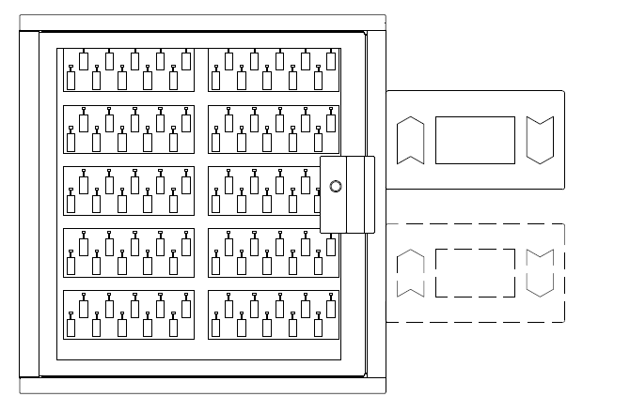

Right side installation

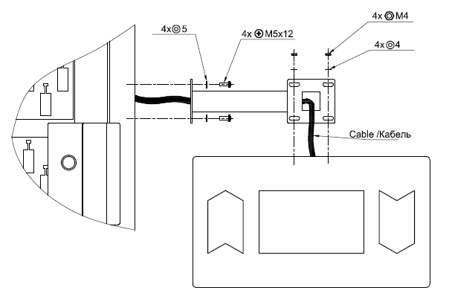

Right side installation

To install the control panel, preliminary, it is necessary to knock out a square hole for the connection of the connecting wires. The hole has a slot on the contour of the laser and is easily removed. Similar round holes are located along the entire perimeter of the cabinet. They can be used to connect power wires and communication interfaces.
The brackets of the control panel have some freedom of fastening, which makes it possible to precisely adjust the position of the panel, push it close, or slightly push the panel away from the housing. The bracket for horizontal fastening to the right of the unit has the ability to rotate about its axis, i.e. Allows you to fix the panel at a small angle.
The panel is connected to the unit by a flat cable to the connector X5 or X6 of the battery charging module and control outputs (Fig. 1). The second connector is used to connect the keys modules.

Ethernet connection
Control panel has a patch-cord Ethernet cable. You could use the adapter (included) if you need longer cable.

Add On cabinet connection
It is possible to connect several Add-on cabinets to the one control panel.
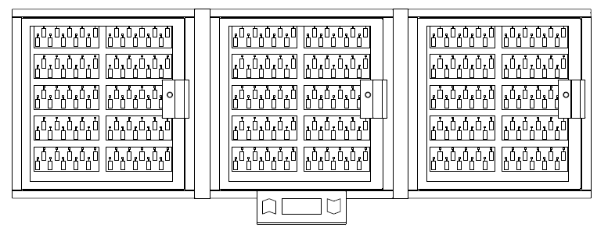

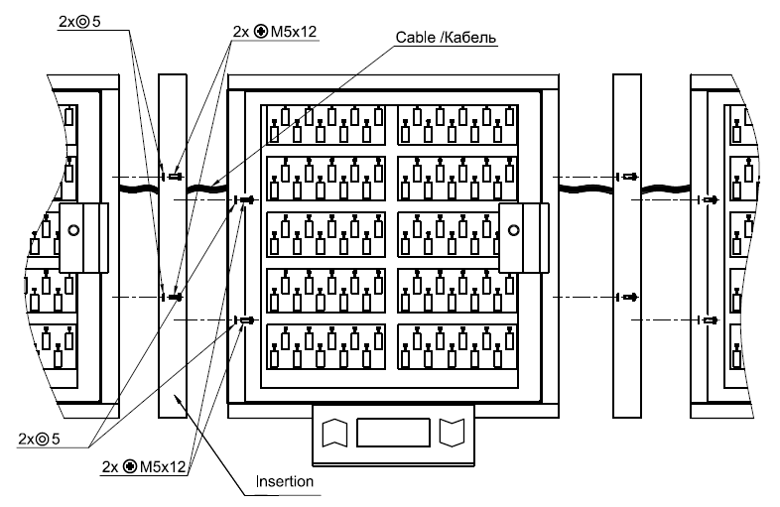

Add-On cabinet connection

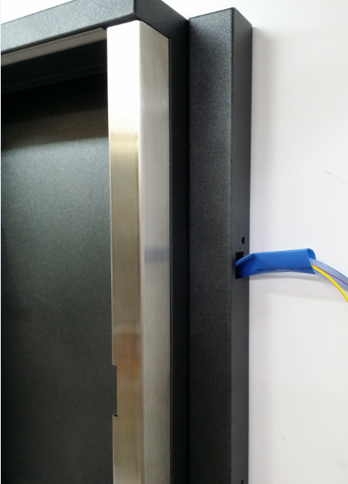
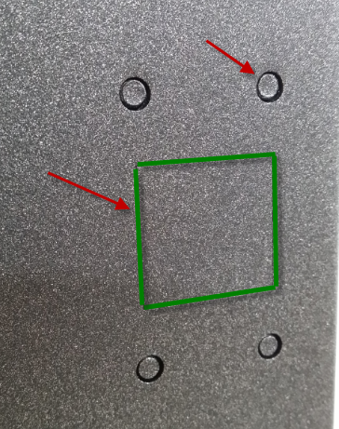

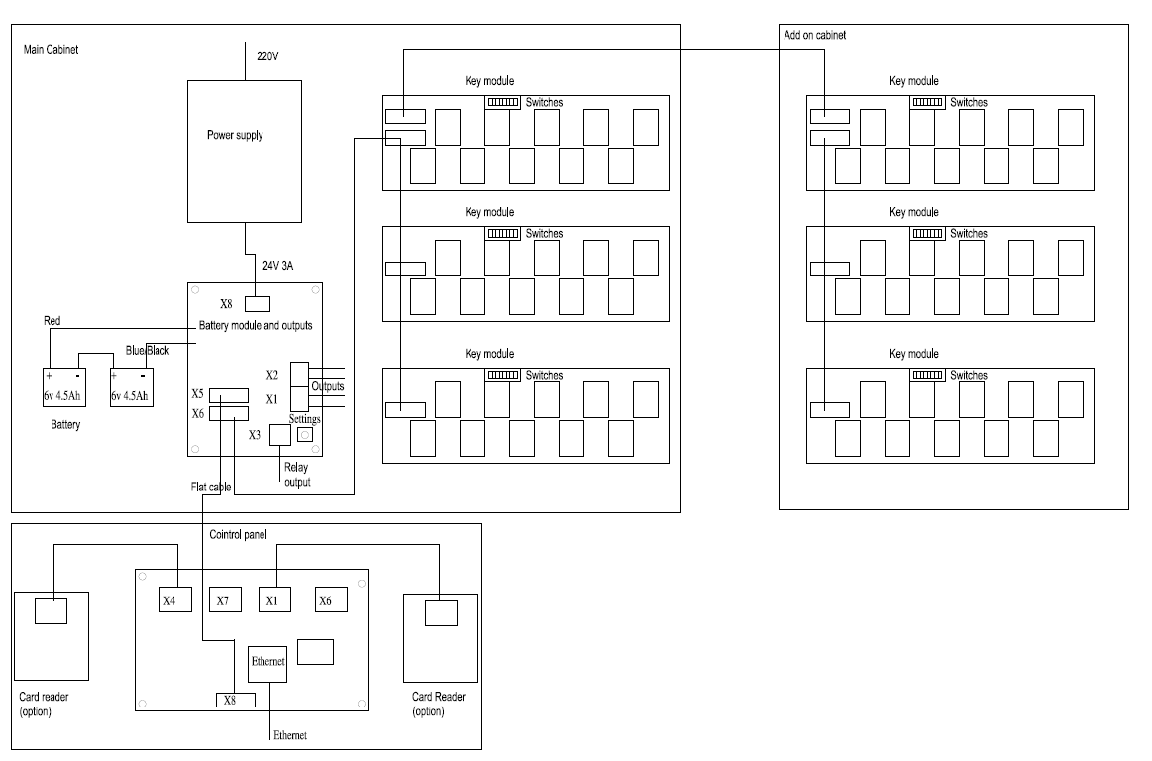

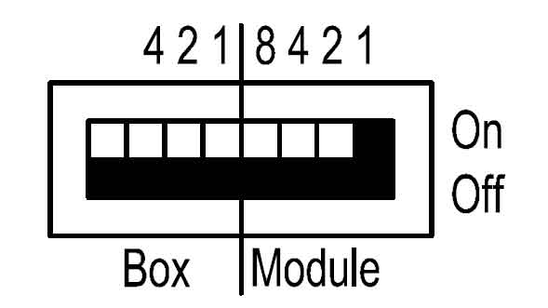
Fig. 1

Attention! It is important to use the insulating tube (included) to protect cable from sharp edges of.
Attention! All Add-on cabinets must be grounded as well as the main cabinet.

For any additional Key module or Add On cabinet it is required to set up the address on a DIP switches on a back panel of key modules. Left 4 switches set up the cabinet number and the right switches the module number.

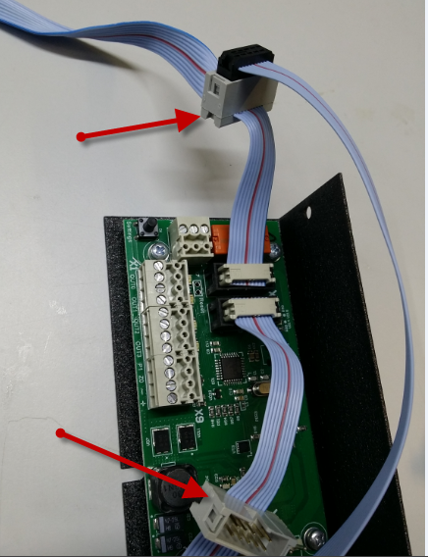
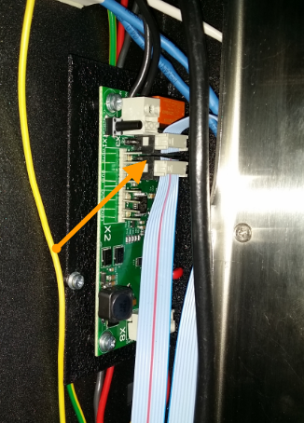

For your convenience flat cables for the Add-On cabinets and control panel are additionally equipped with the extra sockets male and female. So you could plug and play add on cabinets in any side.
It is not possible to make a mistake with the sockets all connectors are identical.

Connection of control signals
System could trigger up to 5 control signals from Battery module. You could link those signals to the Building Alarm system or to CCTV systems. Outputs could be programmed to the different events: alarm, faults, door open, close, key return and remove and so on.
X1, X2 connectors have 4 solid state relays. Contacts are 250v 100mA 30 Om.

Connectors X1, X2
OUT0 | Output 0
OUT0 | Output 0
OUT1 | Output 1
OUT1 | Output 1
OUT2 | Output 2
OUT2 | Output 2
OUT3 | Output 3
OUT3 | Output 3
Connector X3(NO/NC relay) 250V 5A
С | Common
NC | Normal Close
NO | Normal Open

Programming of the outputs and relays is carried out via the SecuriProx Studio configuration program.
Connectors are removable. You can remove the connector to connect the wires and put it back on later.

Card Reader replacement
If necessary, you can use readers of a different format. To do this, you must turn off the readers that come with the kit and connect the new ones to the X4 and X1 connectors of the control panel. Use the +, -, D0, D1 terminals.
The format of the reader is selected using the SecuriProx Studio configuration program. The controller understands Wiegand interface up to 82 bits.
Connectors X4, X1 Control panel

+ | +12 V
- | GND
D0 | Data 0
D1 | Data 1

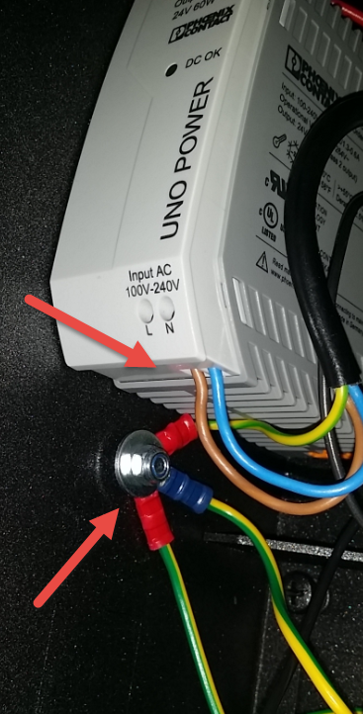
Mains and Ground connection
The key storage system has an internal input voltage of 24V with automatic switching to battery operation. For operation from 90-240V the standard power supply unit from “Phoenix contact” is delivered.
The mains connection should be done to the terminal «L» for the «Line» (in general brown wire) and to the terminal «N» for the «Neutral» wire (in general blue). For your convenience it is possible that the Key management system will be equipped with the extra switch. IN this case the «Line» wire should be connected to the switch terminal.

Attention ! The metal cabinet of the unit, control panel and all the add-on cabinets must be grounded with a separate grounding wire directly to the common ground of the building.

Battery connection
After installing the entire system and connecting all interfaces, you need to connect the batteries.
Attention ! The system will not start up when only rechargeable batteries are connected. The main power supply is required to start. During normal operation, the system automatically charges batteries and monitors their operability.

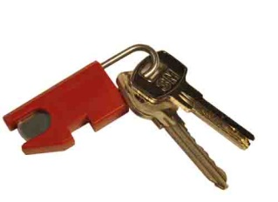
Adding keys
The keys are attached to the key fob with a 3 mm shackle made of stainless steel. Shackle are disposable. Those. After fixing the shackle in the key fob, it can not be pulled out. To replace the key on the key fob, it is necessary to cut the shackle (bottom) at the base of the key fob. A new ring with a new key should push the remainder of the old shackle into the key fob and fix the new shackle. The Key Fob has a chip with a unique number so the system could recognize the key by its key fob. Programming of the key fob, key name and number is possible with the help of the program SecuriProx Studio (supplied).
With the help of software, you can read information from key storage systems for all unknown keyfobs (new keyfobs not entered into the system).

Use of sealed key boxes
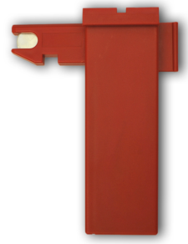
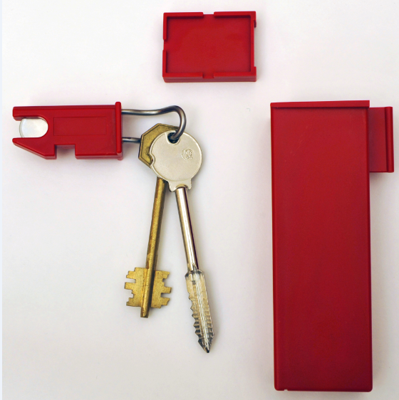
In order to increase security, it is possible to use key boxes to store keys. In this case, the keys are also attached to intelligent key fobs with a unique chip, and then the key with the key fob is inserted into a box, which can be sealed in the standard way. The delivery kit can include standard-size boxes (70 mm) and elongated boxes for long safe keys of up to 105 mm long (the size from the center of the hole to the tip of the key)

Maintenance
Key storage requires service.
Periodically (once a year or more often if necessary), it is necessary to lubricate the door hinges, movable parts of the lock (tongue) and the electro-latch with a silicone lubricant spray.

Initial system startup
The system is programmed using SecuriProx Studio software (included in the package). In order for the key storage system to initially connect to the SecuriProx Studio server, you must set the IP address of the device, the server's IP address and other network parameters on the key storage system.

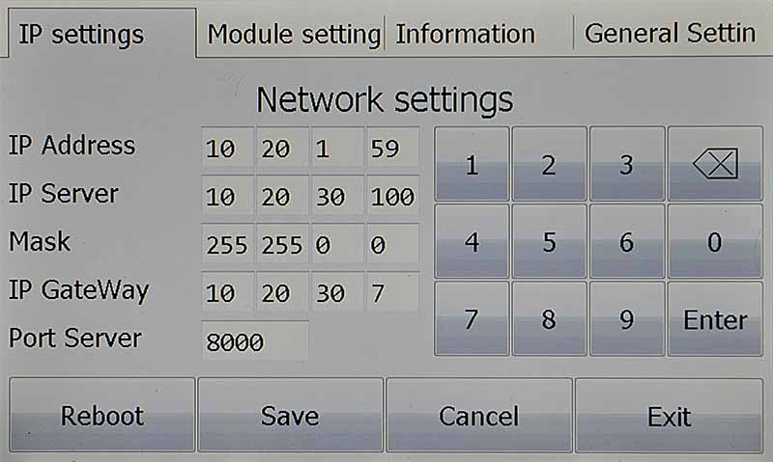

To enter the initial settings mode, press the Settings button on the battery charging module (located inside the main unit from the right side). On the tab "IP settings" it is necessary to set the IP address of the device, the IP address of the server, and other network parameters. The default port of the server is 8000. If this port is already occupied on the server, then it is possible to change it. In this case, you must also change the port number and on the server itself. See the installation instructions for the software. To apply the changed settings, you must save them and reboot the device.

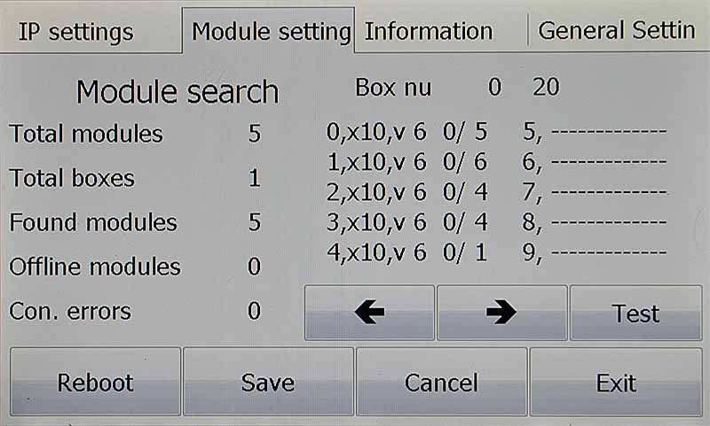
The "Module Settings" tab allows you to check the connection with all key modules in the system. When the power is turned on, the system automatically searches for all connected modules and remembers their presence.
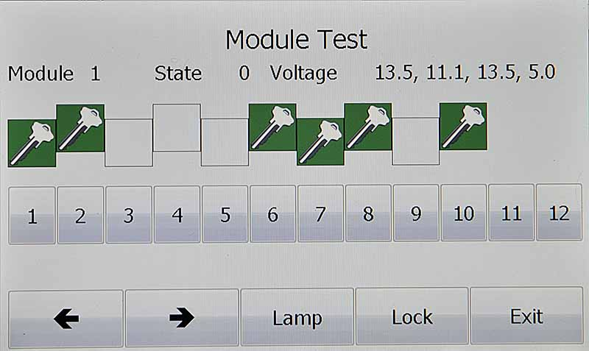
The "Test" button is available on the "Module Settings" tab. This option allows you to test the cells for the keys presence, to check up the solenoids operation, Switch On the upper light and unlock the door lock.

On the "Information" tab, you can see the serial number and version of the device, voltage settings. Including voltage and internal resistance of the battery. Check up the readers operation. There are also available the operating time since the last switching on and the total number of door openings.

Operator Manual

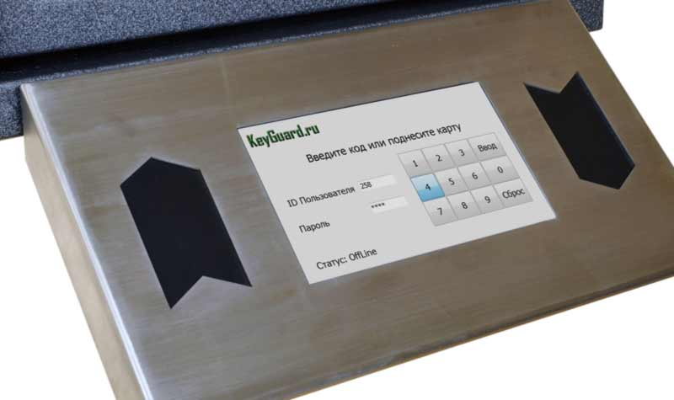
SIMPLE AND CONVENIENT
A large touch screen allows not only to manage the key storage system simply and easily, but also to quickly get any information you are interesting. For example who and when got the key or which key cabinet within the site contains an actual key. You can also generate and print reports of any kind with the software provided in the kit.
Two Wiegand readers (hand in/ hand out) and a fingerprint reader from the world leader in biometric technologies of the French company Morpho Safran are could be integrated into the display case. The system allows access to the key storages without entering any additional information - all you need is a card or a fingerprint. When integrating with security alarm systems, messages from the security alarm can be displayed on-line. In particular, object protection status and confirmation of zone installation/ removal.

Configuring access modes for keys
All system settings are carried out using SecuriProx Studio software (included in the package). To configure users, keys, key lists, time zones, access levels, and report generation, see the description for the SecuriProx Studio software package.

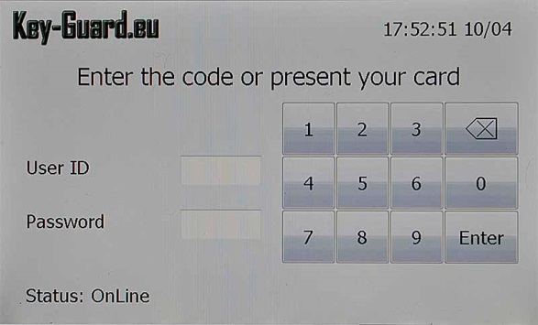
Issuing a key
To get a key present your card to the right reader (with a card reader option) or enter you ID and Password. In the case the Card & Code option set. You should present your card And enter the Password.

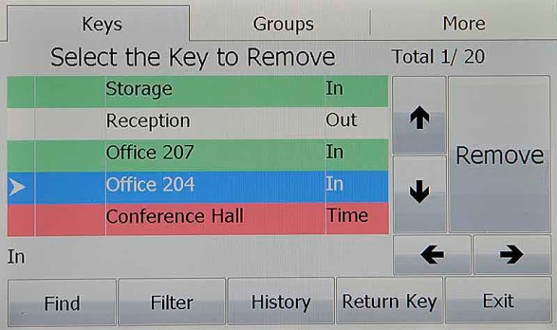
For the finger print reader option you could present your finger for the authorization. In this case there is possibility to set up different access level for the different fingers. For example for the first (if you’re a manager and have access to all the doors) for the first finger you could set up the full access to the system and for the second finger you could set up only your room key. In this case you could use the second finger for everyday use and the first one in case of emergency.
In case you are allowed to get single key. The system will unlock the door and light up and unlock the cell with your key.

In case you are allowed to take several keys to you will get a menu with only your key list. You could check the status of keys (In, Out, Blocked, Wrong time to get)
You can choose one or several keys and press Remove button. System will open the door and show you location and unlock the cells of the keys.
To make things easy there are some options you could use.

- Filter – Remove from the list all the keys which is Out, blocked or prohibited to take by time. You will see only available and allowed for you to take keys.
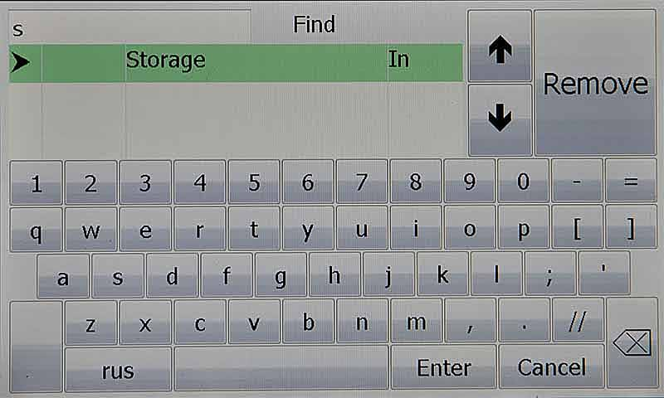
- Find – You could search you key in a list. You could enter the name of the key or key number. In case you found list of keys you could choose one or several key and press remove button or get back to the main screen to continue.
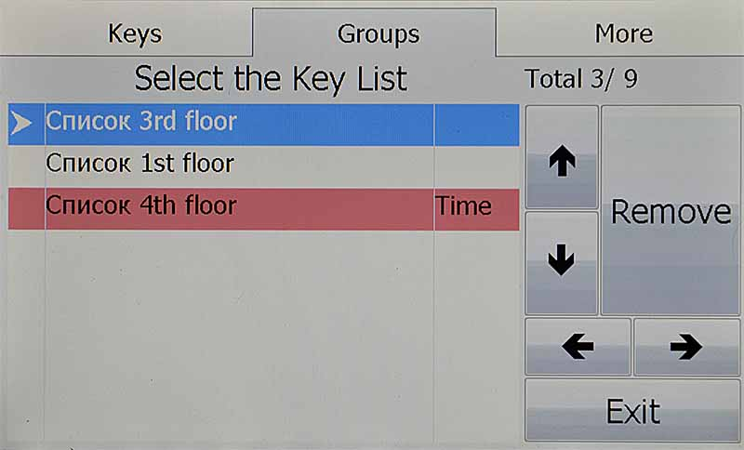
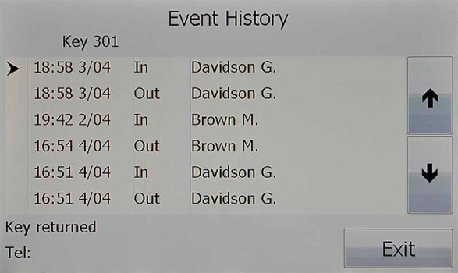
- Groups – There is a possibility to get a whole group of keys. You need to press Group tab, choose the required group of keys or several groups of keys and press remove or exit to continue. The group of keys could have a time zone. In case you come to the wrong time it will be back light by RED and have a status Time – that means that you no permission to get this keys in this moment.

- Hostory – The last 16 events by every key is available directly from the touch screen of the control panel. Time & Date, event (In, Out & alarms) The person name and phone number also available in case it is enabled by software.
- Return – You always could switch to return mode.

As soon as you choose key, several keys or group of keys just press Remove button. The system will unlock the door. In case several cabinets are present. The requared cabinet will be indicated by Flash Strip light at the top. When you open the Door The requared Cell will Flash and unlocks. You could take keys ione by one. After receiving all the keys you should close the door. The alarm will be triggered in case you will forget. All the time settings (open the door, unlock the cell and close the door you could adjust in the software). There is an option to disable door sensor. In this case no alarm will triggered in case you will not close the door in time.
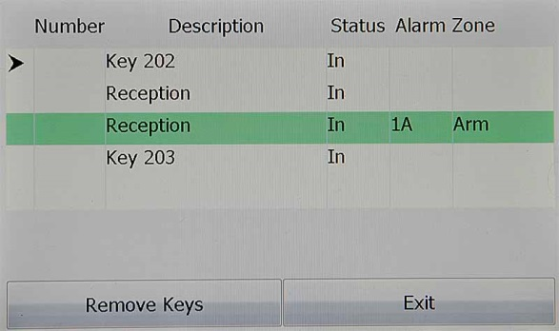
All the removed returned keys will be shown on a screen.
In case the system has a link to security system you will see the report to Arm of alarm zone.

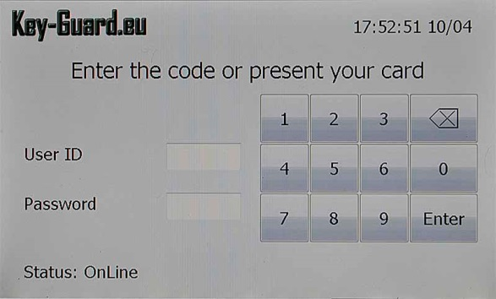
Return keys

To return the key or group of keys you should present your card to the left reader or enter ID and Password.
You are allowed to return the key in any location. The system will read the Key Fob information and recognize the key and remember it location. The next day you will get this key from this location.
As soon you return all the key you should close the door. Alarm will be triggered in case too is not closed.

Emergency release of the keys
In case of a fault of the system there is an option to get keys manually. You should open the front door by emergency key, the same key will open the inner door. As soon you the inner compartment you could release keys by pooling magnets pins of the keys.

Technical data

General
Number of keys | 10… 2000 for one control panel
Number of cabinets | Up to 20
Power
Nominal input voltage range | 100 V AC ... 240 V AC
AC input voltage range | 85 V AC ... 264 V AC
AC frequency range | 45 Hz ... 65 Hz
Choice of suitable entry fuses | 6 A ... 16 A
Power consumption | 60 Wt max
Internal voltage | 24V/14V
Battery | 6V 4.5Ач Fiamm FG10451 2 pcs
Operation from battery | Up to 20 h
Ambient condition
Ambient temperature | -30 °C ... 60 °C
Max. permissible relative humidity | ≤95%  (at 25 °C, no condensation)
Housing
Steel  With stainless steel insertion | 2 mm
IP protection | IP 20
Dimension W/H/D 5 mod cabinet  Dimension W/H/D 10 mod cabinet | 430 mm x 742 mm x 132 mm  715 mm x 742 mm x 132 mm
Control panel Dimension W/H/D | 350 mm х 193 mm х 38 mm
Color dark model  Color light model | dark silver 5359AO445  RAL7038
Emergency release mode
Abloy mechanical (HSS) lock to unlock main and internal doors. | Included
Package
Weight 5 mod cabinet  Weight 10 mod cabinet | 35 kg  50 kg
Package size 5 mod cabinet W/H/D  Package size 10 mod cabinet W/H/D | 550 mm х 880 mm х 250 mm  820 mm х 880 mm х 250 mm
Security
Door contract | Biased reed are resistant to defeat by external magnets
Alarm outputs | 5
Outputs
Outputs (free programmable) | 4 outputs 250V 0.1A 30Om  1 relay output NO, NC 250V 5A
Interfaces
Ethernet | 10/100 mbit
Wiegand interface | 2 interfaces / 24 – 80 bit
Door options
Glass door | Available (Polycarbonate)
Steel door | Available
No door | Available
Memory
User memory | 50 000 (more on request)
Event memory | 50 000 (more on request)
TFT
Super bright 7” with capacity touch panel
SmartKey
Technology | Dallas 1-wire
Clamp | Stainless steel 3 mm
Software
Configuration module | Included
Graphical maps module | Included
Email alert module | Included
Report module | Included
Card Print module | Included

